Given two integer arrays preorder and inorder where preorder is the preorder
traversal of a binary tree and inorder is the inorder traversal of the same tree,
construct and return the binary tree.
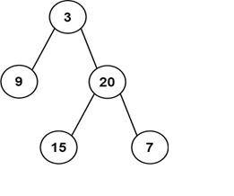
Input: preorder = [3,9,20,15,7], inorder = [9,3,15,20,7]
Output: [3,9,20,null,null,15,7]
